|  |  |
| --- | --- |
| Course Name | ITD 2313 – Script Programming |
| Instructor | Mark Pranger |
| Student Name | Josh Jones |
| Due date | May 12 |
| Grade | <grade earned here> |
| Grading Comments | <instructor comments here> |

Page 42:

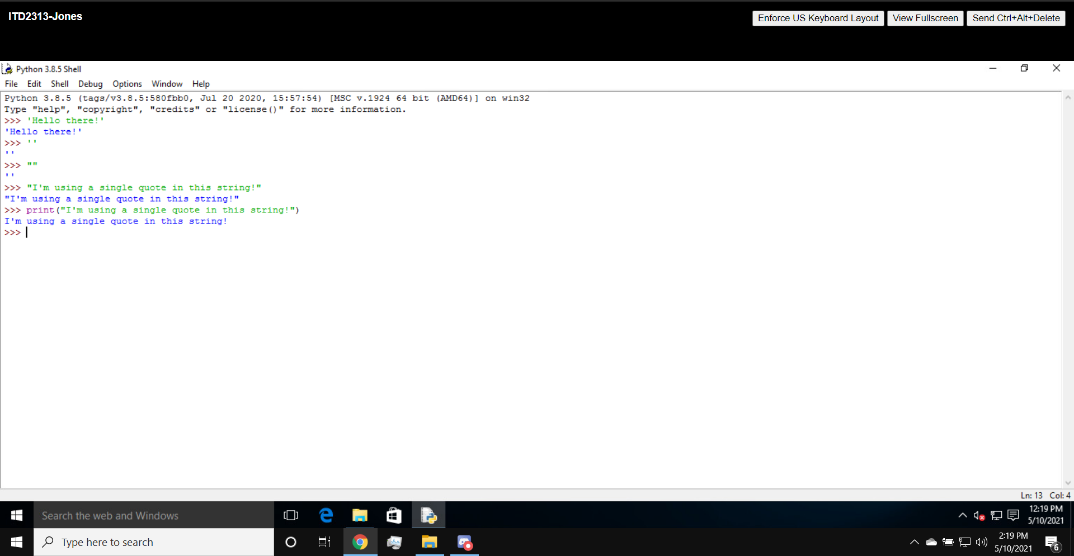

Page 43:

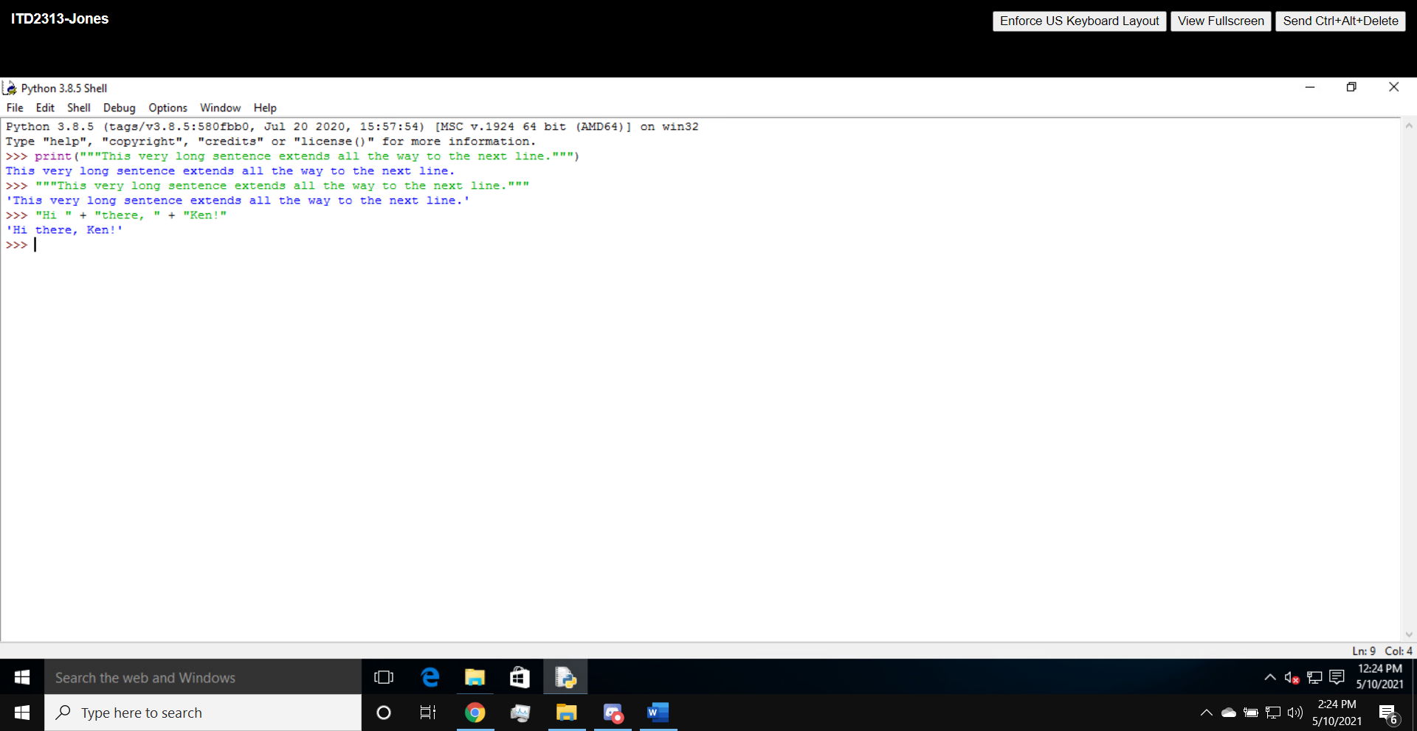

Page 44:

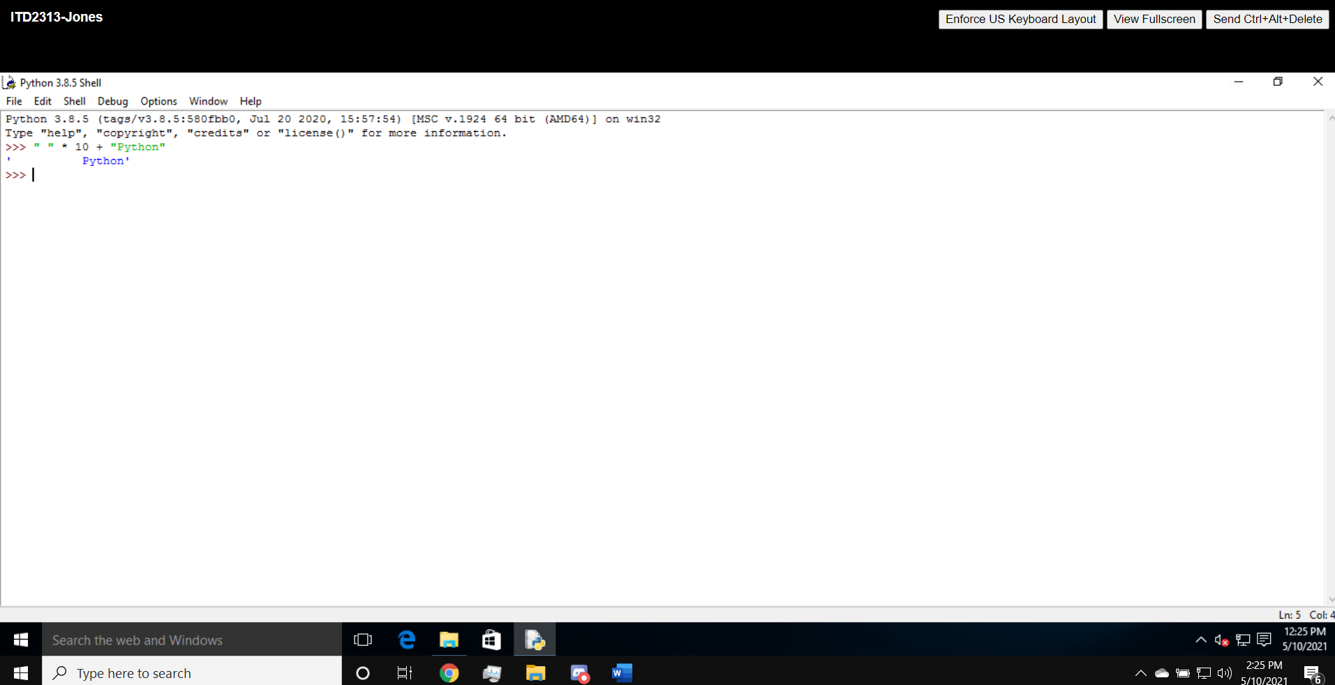

Page 45:

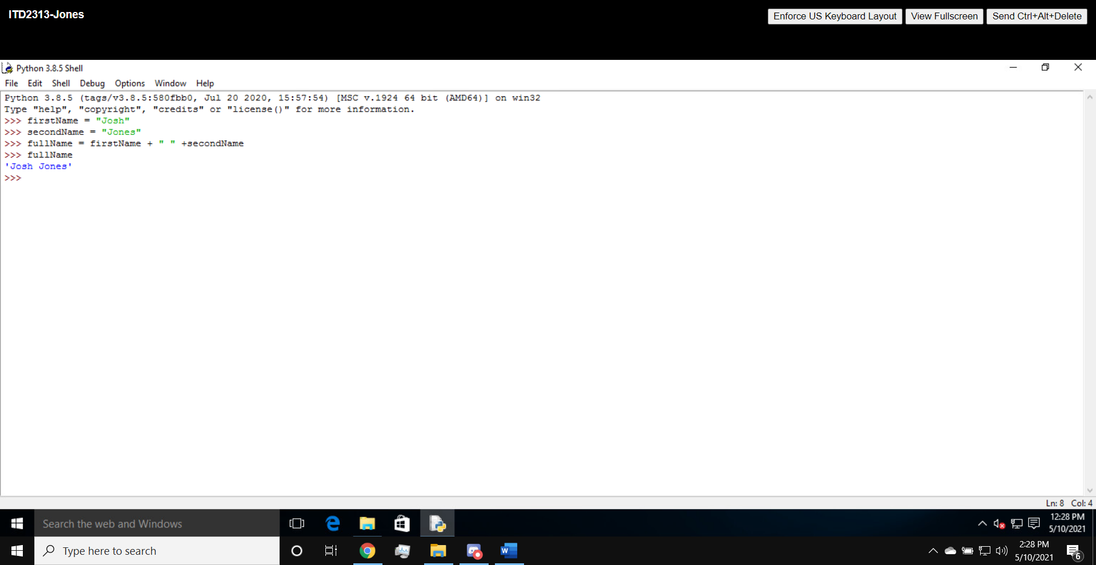

Page 49:

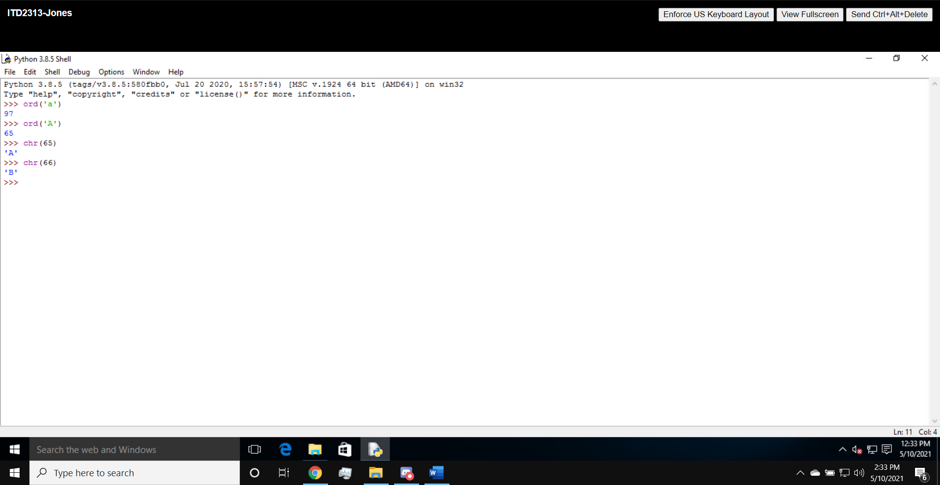

Page 51:

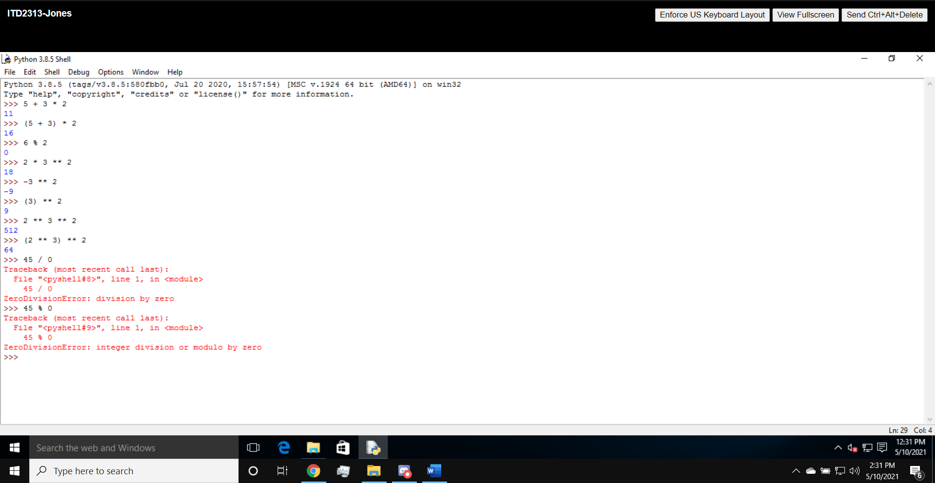

Page 52:

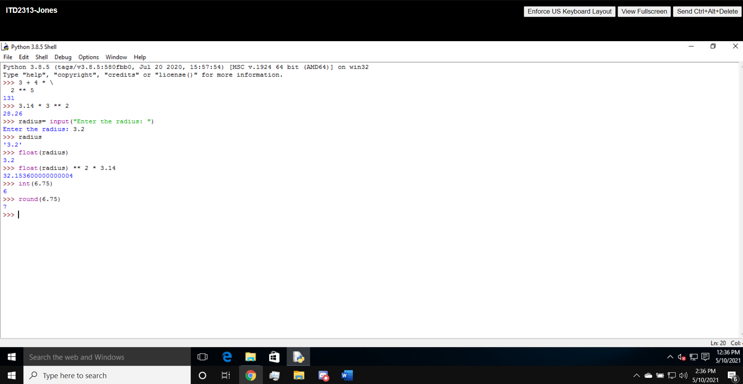

Page 53:

